**CLOUD COMPUTING NOTES**

**What is Hypervisor?**

Hypervisor is a program that allows multiple Operating Systems to share a single physical hardware. Each operating system will share the host’s processor, memory, file storage, and other resources. The hypervisor controls the host processor and resources, allocating what is needed to each operating system. This ensures that he the guest operating systems (called virtual machines) cannot interrupt each other.

Since Hypervisors help create and manage virtual machines (VMs), they are also known as Virtual Machine Monitors or **VMMs**.

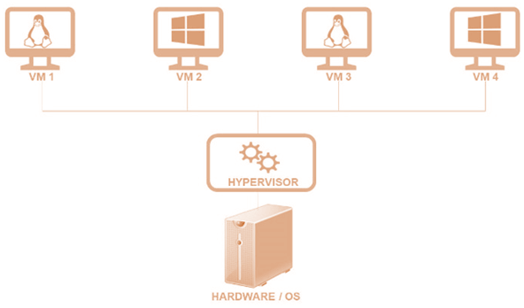

Hypervisors help you retain control over a cloud environment’s processes and infrastructure and protect sensitive data. It makes cloud-based applications accessible to users in a virtual environment.

## Types of Hypervisors

There are 2 types of Hypervisors, as detailed below:

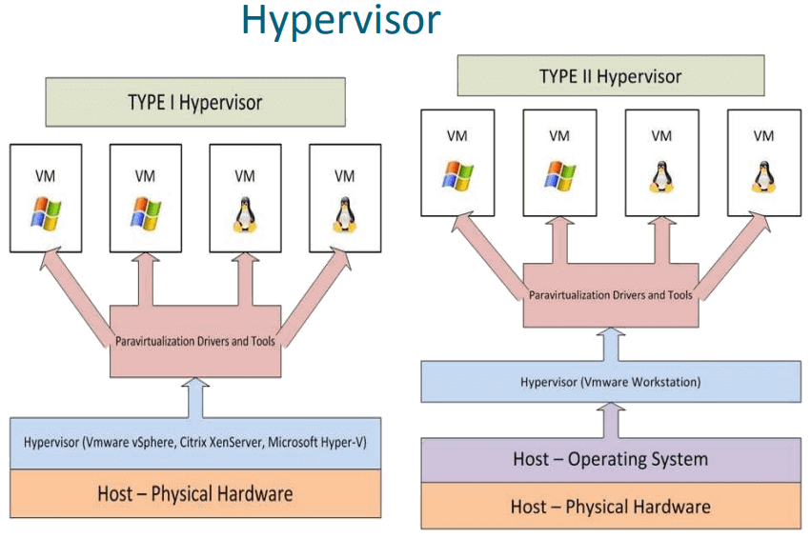

### **Type 1 Hypervisor**

Type 1 Hypervisor is installed directly on the physical server, also called a “**bare metal**” Hypervisor. You can also have direct access to the resource of the physical server, which makes the Type 1 Hypervisor highly effective. Furthermore, the design of the Type 1 Hypervisor is highly secure, as it limits the attack surface and the potential for compromise.

Type 1 Hypervisors are the most common choice within the enterprise IT context as it offers strong security, stability, and performance.

Popular Type 1 hypervisors are [Nutanix AHV](https://www.nutanix.com/products/ahv), [VMware ESXi](https://www.nutanix.com/vmware), [Citrix Hypervisor](https://www.nutanix.com/solutions/vdi/citrix) amongst others.

### **Type 2 Hypervisor**

Type 2 Hypervisors run as applications on a physical server’s pre-existing OS. The host operating system, sits between the physical server and the Hypervisor. So, it is also called “hosted” Hypervisors.

However, Type 2 Hypervisors are not a good choice for server-based environments, as they have higher latency and risk exposure than Type 1. Type 2 Hypervisors are easy to install. It can work well in specific use cases, like individual PC users who want to run only one OS. In such cases, performance and security are not principal concerns.

Example: Installing [Linux over Windows using VirtualBox](https://www.guru99.com/install-linux.html#installing-linux-using-virtual-machine)

**What is a Cloud Hypervisor?**

A Cloud Hypervisor is a software solution that enables you to share the physical computing and memory resources of a cloud provider across multiple virtual machines (VMs).

It was created for mainframe computers in the 1960s. Cloud Hypervisors gained worldwide popularity with introduction of VMware for industry-standard servers in the 1990s.

**Cloud Hypervisor** allows the single physical server to run multiple guest Virtual Machines. These VM’s each have their own operating systems (OSs) that run independently and are logically separated from each other. Because of this problems or crashes in one guest VM have no effect on the other guest VMs, OSs, or it’s running applications.

**Why do you need a Cloud Hypervisor?**

Suppose you own a company with multiple servers that provide various services to customers via the internet. In that situation, it isn’t easy to centrally handle them, particularly those running different operating systems.

A Hypervisor allows you to virtualize these servers and manage them all in one physical machine, making them more efficient. It also helps you to control the data flow into the virtual machines managed by the Hypervisor.

Hypervisor also acts as a storage center where all the data is stored virtually.

**How does a Cloud Hypervisor work?**

Following 3 modules are used in a HyperVisor

* **Dispatcher:**  This module acts as an entry point for the Virtual monitor. It also reroutes all the virtual machine instructions to one or both modules listed below.
* **Allocator:**  The allocator is responsible for deciding the system resources to be provided to the virtual machine instance. In other words, the dispatcher invokes the allocator whenever a virtual machine executes an instruction that results in changing machine resources associated with the virtual machine.
* **Interpreter:**  The interpreter module contains routines executed whenever a virtual machine executes specific privileged instructions.

**Benefits of a Cloud Hypervisor**

Here are some important advantages/pros of Cloud Hypervisor:

* **Portability:** Applications that experience spikes in demand can connect two additional machines to scale as needed. It becomes possible as hypervisors allow workloads to move between two different virtual machines.
* **Efficiency:** One physical server can be used more effectively when multiple virtual machines run on one physical machine’s resources, thanks to Hypervisors.
* **Utilization:** Hypervisors allow multiple virtual machines (VMs) to run on a single physical server and share resources. Thus, it increases server utilization while saving on power, cooling, etc.
* **Hardware neutral:** Hypervisor-based replication is hardware neutral, meaning duplicate data can easily be stored on any device.
* **Flexibility:** The Hypervisor guest VMs and OSs on a wide range of hardware.
* **Time to use:**Cloud Hypervisors enable virtual machines (VMs) to be instantly turned up or down. It allows projects to be created and teams to work on the same day.
* **Reliability:** Hardware failures can be remedied by moving virtual machines to different machines.

## Container vs. Hypervisor

Containers and Hypervisors are involved in making applications faster and highly efficient. However, they achieve this same goal differently.

Here are some important differences between Container and Hypervisor:

| **Containers** | **Hypervisor** |
| --- | --- |
| Containers as a service is a type of infrastructure primarily geared toward running a single application. | A Hypervisor also called a virtual machine monitor, is software that creates and runs virtual machines (VMs). |
| It can run on any operating system. The only requirement is a corresponding container engine. | It shares virtual computing, storage, and memory resources. |
| It allows applications to run without the need for an operating system. | It allows an OS to run independently from the underlying hardware using virtual machines. |
| They are extremely portable because an application contains everything it requires for running. | It can run on multiple operating systems or be installed on the standard operating system. |

## How to choose the right Hypervisor?

Here are important things you need to consider for selecting the right Hypervisor:

* **The cost of a Hypervisor:** The most significant determining factor in selecting a Hypervisor should be to strike the right balance between cost and functionality. Several entry-level solutions are free but do not offer the necessary features.
* **Virtual machine performance:** Virtual systems should be able to meet or even exceed the performance of their physical counterparts, so everything beyond meeting this benchmark is undoubtedly profitable.
* **Ecosystem:** Selecting a Hypervisor with a great ecosystem is also essential. It’s desirable to have documentation, support, training, third-party developers, and consultancies available for your chosen Hypervisor.
* **Test yourself:**You can run various Hypervisor systems and determine which is right. It can be tested on your existing Desktop or Laptop.
* **Performance** – It should be able to deliver enough performance to support your mission-critical applications.
* **OS Support**–Does it support popular guest operating systems like Microsoft, Suse, RedHat, Ubuntu, and CentOS.

## Example of Hypervisor

Here are some famous examples of Hypervisors:

* **KVM:** KVM is virtualization software that provides virtualization infrastructure and a processor-specific module. It enables you to run multiple virtual machines on unmodified Images on Windows or Linux operating systems. It also helps you to do scheduling and resource control.
* **VSphere:**VMware vSphere is a server virtualization software application from VMware. IT departments can run application workloads on the most efficient and cost-effective computer resources. It offers an effective central management system for hosting multiple machines or servers using virtualization.
* **XenServer:** Citrix XenServer is an open-source server virtualization platform based on the Xen Hypervisor. This Hypervisor platform enables the creation and management of virtualized server infrastructure.

### Summary:

* A Hypervisor also called a VMM (virtual machine monitor), is software that creates and runs virtual machines (VMs).
* Hypervisors use one or more systems available resources and provide greater IT versatility.
* Two types of Hypervisors are Type 1 and Type 2.
* A Cloud Hypervisor is software that allows sharing of a cloud provider’s physical computing and memory resources across multiple virtual machines.
* The cost of a Hypervisor, Virtual machine performance.
* Ecosystem, Test for yourself, performance, ecosystem, etc.
* KVM, VSphere, and XenServer are some most common types of Hype visors.

### **What is live migration?**

Live migration refers to the process of moving a [virtual machine](https://searchservervirtualization.techtarget.com/definition/virtual-machine) (VM) running on one physical host to another host without disrupting normal operations or causing any [downtime](https://www.techtarget.com/whatis/definition/uptime-and-downtime) or other adverse effects for the end user.

Live migration is considered a major step in [virtualization](https://searchservervirtualization.techtarget.com/definition/virtualization). By allowing an entire VM to be moved with a running [operating system](https://www.techtarget.com/whatis/definition/operating-system-OS) (OS), live migration helps accommodate low-disruption fault management, [load balancing](https://www.techtarget.com/searchnetworking/definition/load-balancing) and low-level system maintenance.

Some popular [hypervisor](https://searchservervirtualization.techtarget.com/definition/hypervisor) products that support [guest OS](https://searchservervirtualization.techtarget.com/definition/guest-OS) live migration include VMware vMotion, Microsoft Hyper-V and Oracle Logical Domains (LDoms) software.

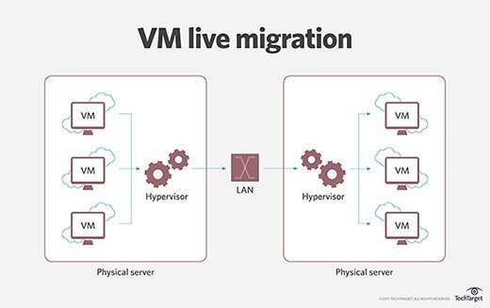Live migration involves moving a virtual machine from one physical host server to another without any adverse effects.

### Understanding live migration

**Live migration is usually performed when a physical host machine (computer or server) needs maintenance or an update, or when a VM must be switched to a different host**. The process transfers the VM [memory](https://www.techtarget.com/whatis/definition/memory), network connectivity and [storage](https://www.techtarget.com/searchstorage/definition/storage). Most of the migration occurs while the OS continues to run.

**The live migration process starts by transferring the data in the VM's memory to the target physical machine. Once all the data is transferred, an "operational resource state" consisting of**[**CPU**](https://www.techtarget.com/whatis/definition/processor)**, memory and storage is created on the target machine.**

**After this, the original VM -- along with its installed applications -- is suspended, copied and initiated on the destination. This entire process causes minimal downtime. Although it's not possible to completely avoid downtime, it can be further reduced with pre-paging and by using the memory's probability density function.**

**Live Migration supports more efficient load balancing, so systems and CPU resources can be shared for optimum use. It also allows applications to continue running while the administrator manages maintenance activities, such as security updates, in the background.**

# **Types of Cloud**

There are the following 4 types of cloud that you can deploy according to the organization's needs-

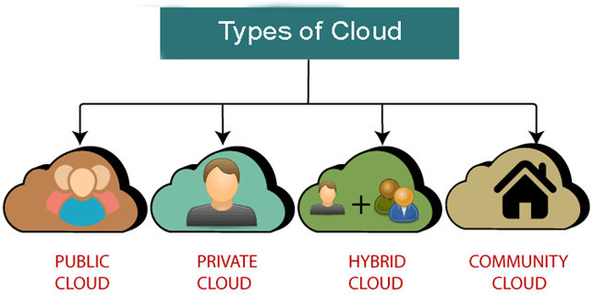

* [Public Cloud](https://www.javatpoint.com/types-of-cloud#Public)
* [Private Cloud](https://www.javatpoint.com/types-of-cloud#Private)
* [Hybrid Cloud](https://www.javatpoint.com/types-of-cloud#Hybrid)
* [Community Cloud](https://www.javatpoint.com/types-of-cloud#Community)

## Public Cloud

Public cloud is **open to all** to store and access information via the Internet using the pay-per-usage method.

In public cloud, computing resources are managed and operated by the Cloud Service Provider (CSP).

**Example:** Amazon elastic compute cloud (EC2), IBM SmartCloud Enterprise, Microsoft, Google App Engine, Windows Azure Services Platform.

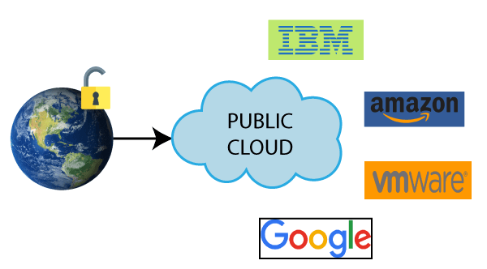

### **Advantages of Public Cloud**

There are the following advantages of Public Cloud -

* Public cloud is owned at a lower cost than the private and hybrid cloud.
* Public cloud is maintained by the cloud service provider, so do not need to worry about the maintenance.
* Public cloud is easier to integrate. Hence it offers a better flexibility approach to consumers.
* Public cloud is location independent because its services are delivered through the internet.
* Public cloud is highly scalable as per the requirement of computing resources.
* It is accessible by the general public, so there is no limit to the number of users.

### **Disadvantages of Public Cloud**

* Public Cloud is less secure because resources are shared publicly.
* Performance depends upon the high-speed internet network link to the cloud provider.
* The Client has no control of data.

## Private Cloud

Private cloud is also known as an **internal cloud** or **corporate cloud**. It is used by organizations to build and manage their own data centers internally or by the third party. It can be deployed using Opensource tools such as Openstack and Eucalyptus.

Based on the location and management, National Institute of Standards and Technology (NIST) divide private cloud into the following two parts-

* On-premise private cloud
* Outsourced private cloud

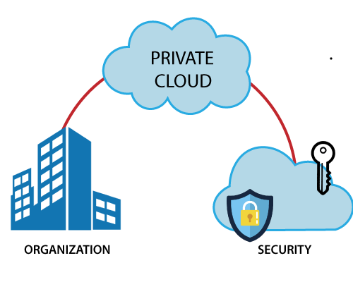

### **Advantages of Private Cloud**

There are the following advantages of the Private Cloud -

* Private cloud provides a high level of security and privacy to the users.
* Private cloud offers better performance with improved speed and space capacity.
* It allows the IT team to quickly allocate and deliver on-demand IT resources.
* The organization has full control over the cloud because it is managed by the organization itself. So, there is no need for the organization to depends on anybody.
* It is suitable for organizations that require a separate cloud for their personal use and data security is the first priority.

### **Disadvantages of Private Cloud**

* Skilled people are required to manage and operate cloud services.
* Private cloud is accessible within the organization, so the area of operations is limited.
* Private cloud is not suitable for organizations that have a high user base, and organizations that do not have the prebuilt infrastructure, sufficient manpower to maintain and manage the cloud.

## Hybrid Cloud

Hybrid Cloud is a combination of the public cloud and the private cloud. we can say:

**Hybrid Cloud = Public Cloud + Private Cloud**

Hybrid cloud is partially secure because the services which are running on the public cloud can be accessed by anyone, while the services which are running on a private cloud can be accessed only by the organization's users.

**Example:** Google Application Suite (Gmail, Google Apps, and Google Drive), Office 365 (MS Office on the Web and One Drive), Amazon Web Services.

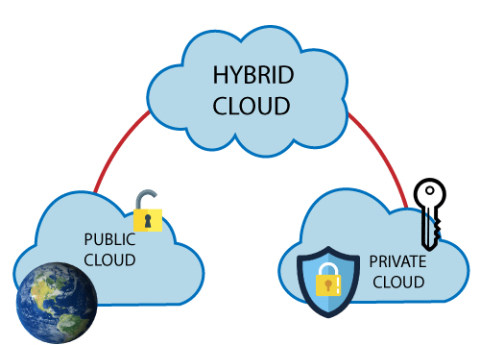

### **Advantages of Hybrid Cloud**

There are the following advantages of Hybrid Cloud -

* Hybrid cloud is suitable for organizations that require more security than the public cloud.
* Hybrid cloud helps you to deliver new products and services more quickly.
* Hybrid cloud provides an excellent way to reduce the risk.
* Hybrid cloud offers flexible resources because of the public cloud and secure resources because of the private cloud.

### **Disadvantages of Hybrid Cloud**

* In Hybrid Cloud, security feature is not as good as the private cloud.
* Managing a hybrid cloud is complex because it is difficult to manage more than one type of deployment model.
* In the hybrid cloud, the reliability of the services depends on cloud service providers.

## Community Cloud

Community cloud allows systems and services to be accessible by a group of several organizations to share the information between the organization and a specific community. It is owned, managed, and operated by one or more organizations in the community, a third party, or a combination of them.

**Example:** Health Care community cloud

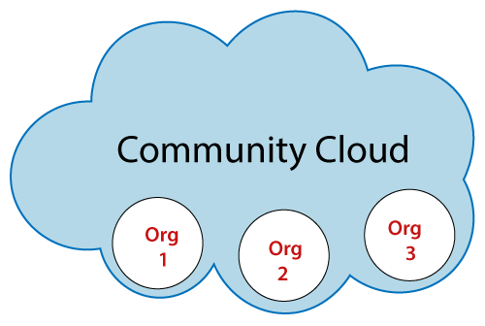

### **Advantages of Community Cloud**

There are the following advantages of Community Cloud -

* Community cloud is cost-effective because the whole cloud is being shared by several organizations or communities.
* Community cloud is suitable for organizations that want to have a collaborative cloud with more security features than the public cloud.
* It provides better security than the public cloud.
* It provdes collaborative and distributive environment.
* Community cloud allows us to share cloud resources, infrastructure, and other capabilities among various organizations.

### **Disadvantages of Community Cloud**

* Community cloud is not a good choice for every organization.
* Security features are not as good as the private cloud.
* It is not suitable if there is no collaboration.
* The fixed amount of data storage and bandwidth is shared among all community members.

## Difference between public cloud, private cloud, hybrid cloud, and community cloud -

The below table shows the difference between public cloud, private cloud, hybrid cloud, and community cloud.

|  |  |  |  |  |
| --- | --- | --- | --- | --- |
| **Parameter** | **Public Cloud** | **Private Cloud** | **Hybrid Cloud** | **Community Cloud** |
| **Host** | Service provider | Enterprise (Third party) | Enterprise (Third party) | Community (Third party) |
| **Users** | General public | Selected users | Selected users | Community members |
| **Access** | Internet | Internet, VPN | Internet, VPN | Internet, VPN |
| **Owner** | Service provider | Enterprise | Enterprise | Community |